SOP for Enable Auto filter Configuration
Step 1
1. We need to download and install PrimaryInteropAssembly by following steps
a. (i) For MS - Office 2007
Go to the URL: http://www.microsoft.com/en-in/download/details.aspx?id=18346 and download the setup
(ii) For MS – Office 2010
Go to the URL: http://www.microsoft.com/en-in/download/details.aspx?id=3508 and download
b. Then double click on downloaded PrimaryInteropAssembly like below Screen shot then extract files in a folder.
c. Then go to Command Prompt change the directory which folder we extracted files
d. After change the directory type in Command msiexec.exe /i O2007pia.msi and Press Enter Key to install it will be installed.
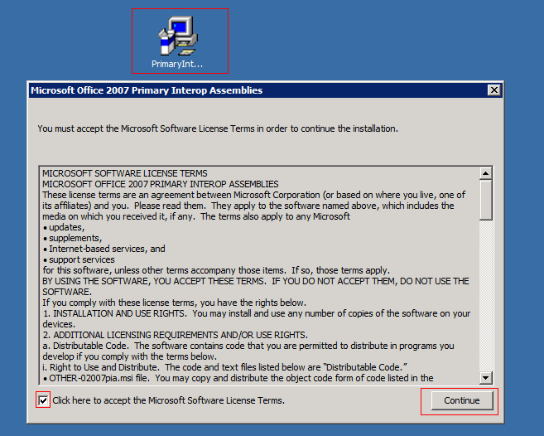
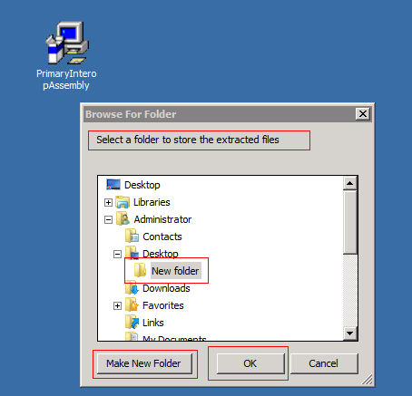

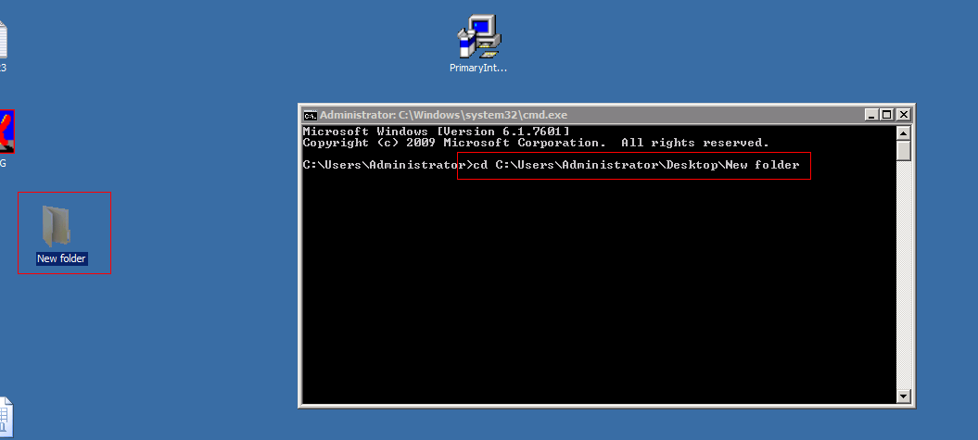

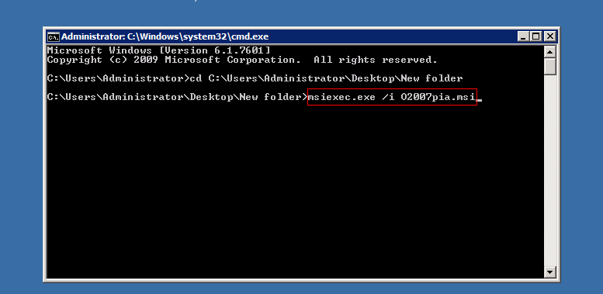
STEP 2. Permission for Desktop Folder
If not available Desktop Folder in the path C:\Windows\SysWOW64\config\systemprofile need to create new folder and name it Desktop (C:\Windows\SysWOW64\config\systemprofile\Desktop). Then need to give all access rights for the Desktop folder Everyone, Network, IIS_Users, IUser, Interactive and Network Service
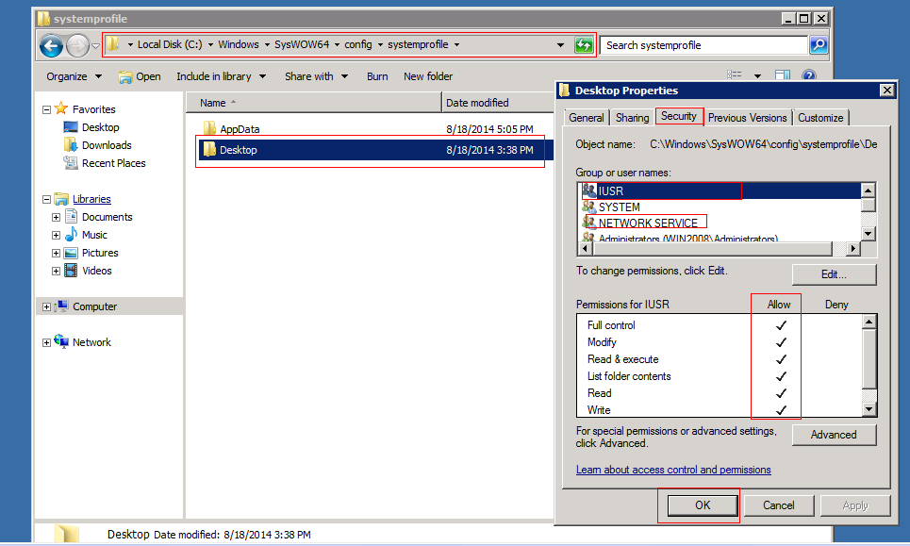

Step 3. COM permissions to the user running the application pool.
a. Start -> Run -> Type dcomcnfg -> press enter Component Services will be popup. Then to the below steps
b. Click on Component Services as like Screen shot
-> Click on Computers
-> Right Click on My Computer and go to Properties and give all rights access for Everyone, Network, IIS_Users, IUser, Interactive and Network Service. Please go through below screen shots.
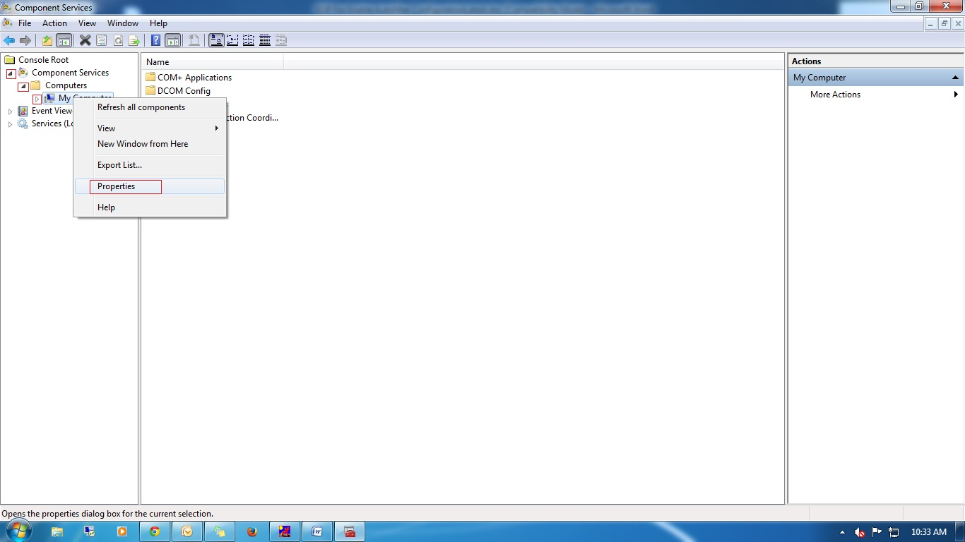

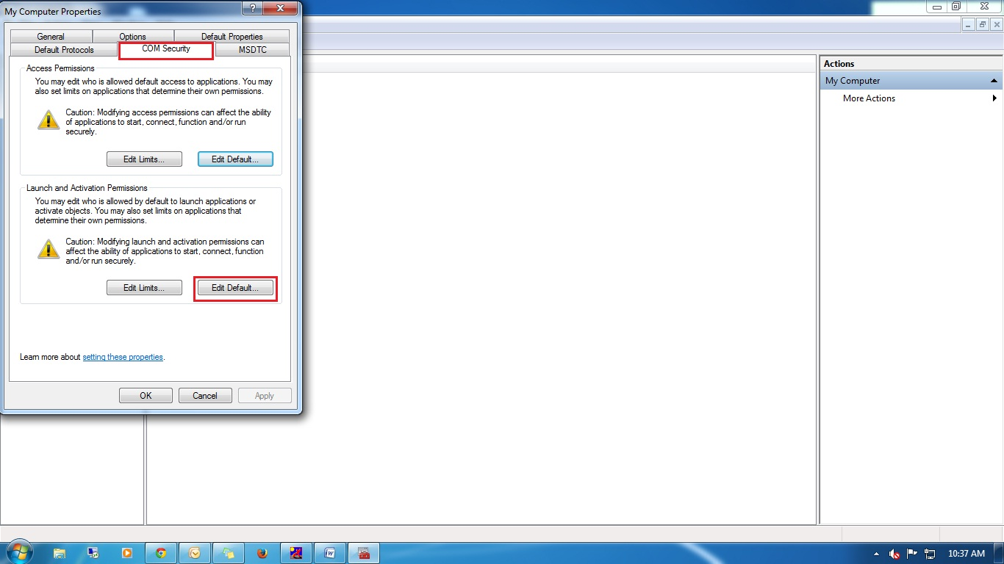
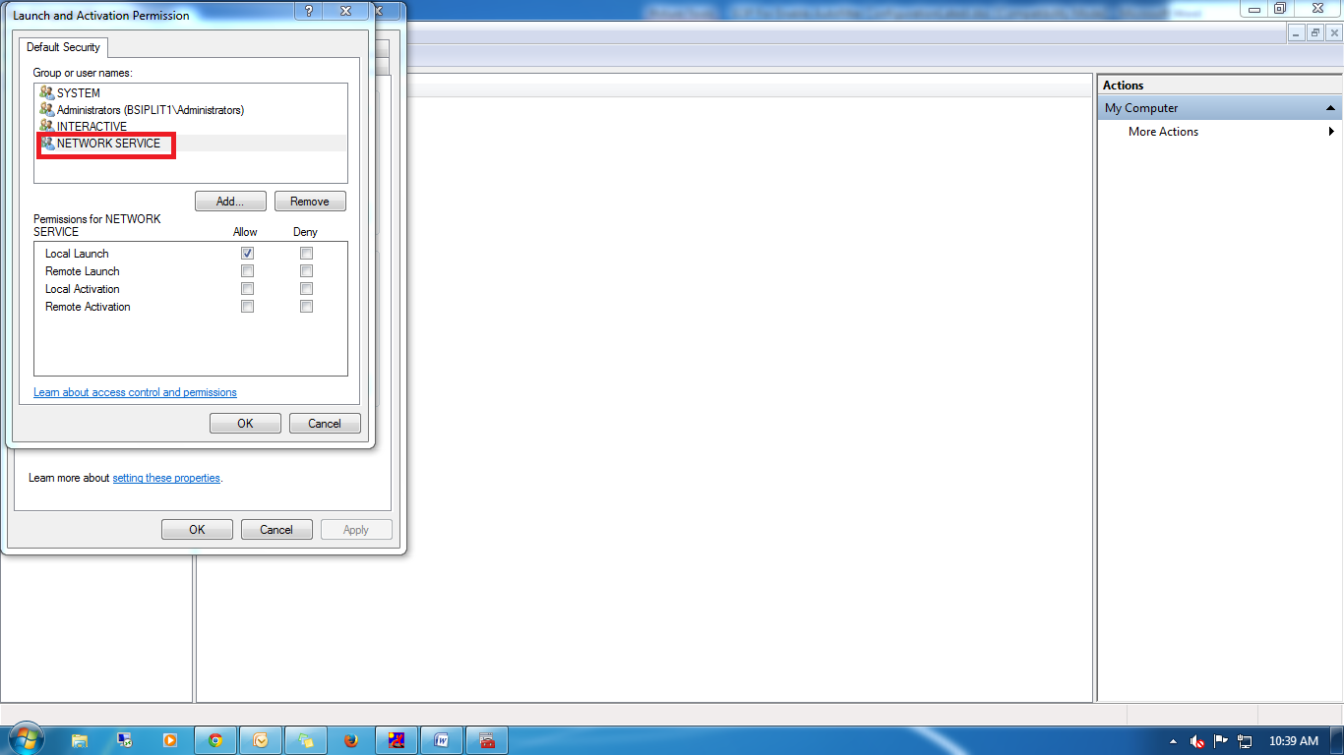
Note:
We need to add IIS users to the default security and give full permission.

Step 4: Enable TRUE Option in IIS Server
Click Run -> inetmgr -> Application Pool -> click on your application -> In right pane select Advanced options -> by default Enable 32 bit application will be false make it as TRUE.
